Design Development of a Rigid-Wing Sail
Roberto Giordano, Gary J Rabone, Marc N Hill, Imre Asztalos, and Thies Gunther
Instituto Superior de Engenharia do Porto
Abstract— At present, the ocean suffers greatly as a result of ever-growing population and disasters occur all over the world. A maneuverable ocean exploring monitoring system has been a state of the art subject for several years. The advancements in the field can be used in several market sectors and developed overtime. This system can be used for research and development purposes. Monitoring the oceans while maintaining the desired energy efficiency measures will be the main goal. This paper presents the development of an innovative rigid-wing for a sailboat likely to sail the oceans and capture data without human interaction. The product will be marketed on several platforms to be used widely in several industries. Many technical aspects still have to be studied and developed, especially regarding the boat that will be subjected to adverse climate conditions in unmanned areas, reducing the human assistance if damage occurs.

Keywords— aerodynamics, autonomous boat, rigid-wing sail

INTRODUCTION
T
his proposition for a robotic sailing is not the first of its kind at the School of Engineering of the Polytechnic of Porto. Autonomous sailboats are gaining growing importance for their potential to maintain a continuous and unassisted operation at the sea surface for long periods of time [1]. The notion is to develop an efficient energy source of locomotion, with controllable parameters to effectively manoeuvre in unattended manner.
It is important to highlight that maritime monitoring field is of notable importance because the oceans (which covers 71% of the Earth's surface and contains 97% of the planet's water [2]) are presently threatened by sustainability complications. Solutions must be expanded and unassisted sailboats might play a decisive role in solving this problem. The ocean’s eco-efficiency is yet to be controlled due to the vastness, therefore
the multipurpose solutions a sailboat can offer is a compliment to future generations.
The proposed solution for a sustainable source of controllable locomotion has been intensely researched and developed in find an innovative concept that is capable of adapting and assisting the environment. Bearing the requirements and pre-requisite results from previous projects in mind the objective of this project is to develop a rigid-wing sail: which can be later installed and controlled in a final autonomous sailboat. The product will also be produced for self-assembly due to the scale of the components and the difficulty of transportation.
Research on the market of ocean monitoring systems has revealed that this is not relatively unique but designs vary indefinitely and innovative products are produced on almost every occasion. The main researched focus of this project is to integrate floatation of a hull body, adapting it to rigid-wing sail and applying controllable variables to optimise manoeuvring actions. These focus points have been addressed on the market although our project and prototype will fill new design modifications from relatable products on the market.
The paper is organized in the following sections. Beginning with Section II, which presents the primary adjustments for the boats and related projects, previously developed. In addition, Section III extensively introduces principle calculations to justify the designs expectation and from this the adopted architecture is produced in IV. The used components and fabrication process of the end product are situated on Section V. In the penultimate Section VI, the experimental evaluation of the design mechanism concept is tasked on the final design. Finally, Section VII concludes the paper, discussing the paper in regards to maintained results obtained and defining future developments.

State of the Art
The research area of boats is an intensive field with centauries of concepts that are continually developed and becoming innovative overtime. The knowledge of these continuous advancements and historical concepts must be comprehended to develop a suitable product of required characteristics. Since our goal is subject to only a rigid-wing sail design the implications of hull installations must be addressed. The hull selection implies a limitation to the sail therefore is a vital research area to achieve a reputable design.

Vessel Preference
The hull is the watertight exterior of a nautical vessel which structure is varied dependent on the operation and classification. These hulls vary structurally and traditionally are mono-hulls, but multi-hull concepts are increasing in popularity as technology advances. The stability variations that contrasting hull designs offer can considerable advantages and disadvantages to vessels depending on the operation location and use. The principles of buoyancy stated by Archimedes indicate, that the volume of the displacement of fluid is equal to the volume of the boat surface volume, which is submerged in the fluid. This also indicates the identical weight in both fluid and boat [REF from WIKI]. These principles signify the hulls ability of floatation due to surface area and differentials in density values.

The hull selection process allowed for a variety of resilient possible designs to be explored and elaborated. Initially the Laser and SKUD18, appear to be viable contenders as both credible features.

Laser
Every Laser in the world is identical. The boat is a challenging boat that rewards athleticism, subtle steering and trimming techniques as well as tactical excellence. [http://shopeu.laserperformance.com/laser/]
[http://shopeu.laserperformance.com/product_images/pdf/Laser%20Brochure.pdf]

SKUD18
SKUD18 has been designed from a performance basis, to offer scintillating, crisp and snappy response to sailors regardless of their mobility. [http://www.skud.org]

Related Work
Currently autonomous sailing is not newly discovered notion to the nautical exploration market nor as previously stated is a first for the School of Engineering of the Polytechnic of Porto. In 2007, FASt [http://paginas.fe.up.pt/~jca/fast/] autonomous sailboat was designed and implemented, focusing on participating in international competitions. The robotic sailboat followed the identical process in fabricating a lightweight kayak, using carbon fibre honeycomb sandwich hull with epoxy resin and plywood reinforced core. Although FASt developed and administered an award-winning product, it lacks crucial consideration rigid-wing sail developments. Therefore other successful projects must be analysed that show a sustained locomotion for rigid-wing sail for accomplishing long missions in the ocean in in grim conditions.

The Saildrone[http://www.saildrone.com/index.php/technology] vehicle is a recent project known for these accomplishments, demonstrated in November 2013 with a 34-day mission from California to Hawaii. The mature Saildrone design is constructed from high strength carbon fibre, creating an extremely durable structure, which freely rotates but is directed into position from the controllable tail This design illustrates a combination of mono-hull and multi-hull features to reduce the payload and enhance the stability, however, this diminishes motion control at speed. Another multi-hull project, ASN Datarmaran [http://www.automarinesys.com/wp-content/uploads/2014/05/Datamaran_DataSheet.pdf] has correspondence with Saildrone while innovational ground has been covered in the development of a dual mode propulsion system. The system consists of a self-trimming rigid wing sail and an electrically powered propeller for tight maneuvering and added speed. The on-demand propulsion system is currently in the testing stage although all considerations of monitoring have been addressed, with an array of communication, control and power devices onboard the vessel.
Under these related circumstances end product is focused on the autonomous sailboat although this project concerns is the rigid-wing sail as the main component of our projected study. We opted to study and analyse these innovative and growing sail types to gather understanding which of locomotion systems that guarantee higher performance and allows reduction in resistance to sustained propulsion strong enough to overcome tidal currents. While, providing an accurate but simple control modulus for a low energy consumption communication and control system.

Project Development

Principle Calculations
This section is focused on the principles in floatation proves the rigid-wings ability to ensure adverse conditions at sea. Using the Laser as our piliminary vessel Impulse moments from the centre of gravity and pressure using the Laser dimensions (Table: 1) to justify the sails capability in navigation according to the design concept, introduced in section IV.

LASER Dimensions [???]
Hull Length | 4.208 m
Hull Height | 0.379 m
Hull Beam | 1.340 m
Volume | 0.931 m³
Rectangular Volume | 5.927 m³
Approx. Total Weight (sail, hull, keel, rudder & equipment) | 225 kg
Table: 1

Hydrostatics
Buoyancy

$\sum{F^{z}}=0$

$$I=W∙g=225×9.81=2207 N (1)$$

$$Draft=\frac{Impulse}{ρ∙g∙A}= (2)$$

Aerodynamics
Wind Velocity…
Impulse = 2250 N
VUW = Volume Under Water
$$VUW= \frac{I}{ρ_{SeaWater}⋅g}=\frac{2250}{1027⋅9.81}=0.223 m^{3}{ (}_{})$$

$$Impulse⋅cosα ⋅ΔD=435.2 Nm (_{})$$

$$Impulse⋅sinα⋅ΔD=490.2 Nm (_{})$$

$$Lifting Moment={Impulse}_{1}+{Impulse}_{2} (_{})$$
$$=435.2+490.2=925.4 Nm$$

$$Lift= \frac{Lift Moment}{cos30⋅(h_{CG}+ h_{CP}+h_{hull)}}=539.9 N (_{})$$

$$Velocity= \sqrt{\frac{2L}{ρ_{air}⋅A⋅Cl}} =15.2 m^{2} (_{})$$

Dynamic equilibrium
Stability & Movement
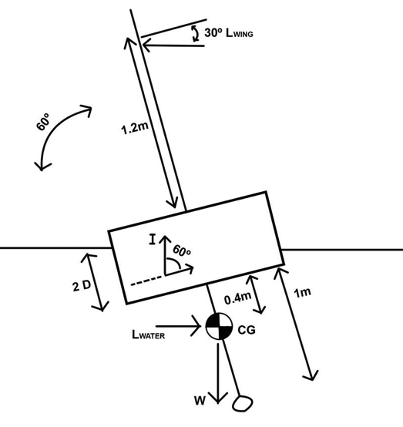
Figure _:
The requirements to reach stability can be summarized in one equation.

UNITS - This applies to papers in data storage. For example, write “15 Gb/cm² (100 Gb/in²).” If you must use mixed units, clearly state the units for each quantity in an equation.
The SI unit for magnetic field strength H is A/m. However, if you wish to use units of T, either refer to magnetic flux density B or magnetic field strength symbolized as µ₀H. Use the center dot to separate compound units, e.g., “A·m².”
Punctuate equations when they are part of a sentence, as in

Refer to “(1),” not “Eq. (1)” or “equation (1),” except at the beginning of a sentence: “Equation (1) is ... .”

Architecture of Developed Wing & Boat
In this section, the architecture for the boat with the rigid-wing sail feature developed for the project is introduced. The goal is to develop a wing sail that can be controlled to optimize positioning and orientation while adapting to the operation environment.

Based on the considered aerodynamic principles and assessments of existing airfoil profiled sails, a NACA 0012 airfoil was adopted for the sail. This airfoil geometry is symmetrical and efficient in controlled easily, as the wing increases vertically these airfoils are reduced in size to reduce sail area, allowing for greater control and less weight. (Fig. __)

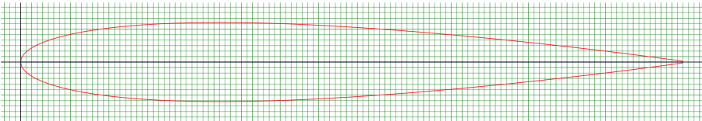
Figure _: NACA 0012 airfoil

Similar to related projects the development, the airfoil

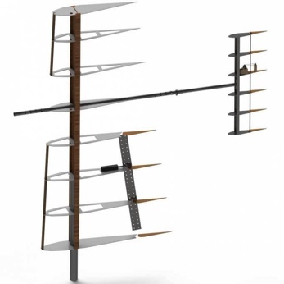
Figure _: Structural interior of the sail

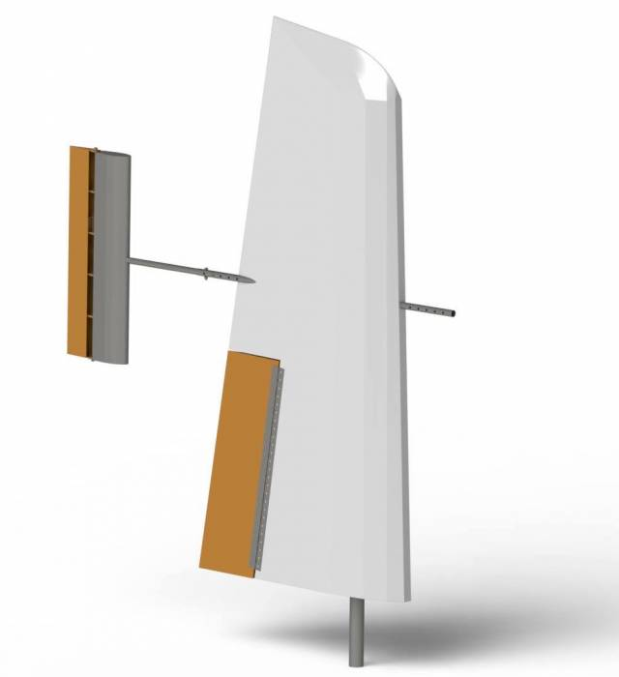
Figure _: Rigid-wing sailed

To comply with the final goal of creating a rigid-wing sail, which can be later assembled to a vessel and operate autonomously. The rigid-wing sail integrates adaptable features: the key wing concept, mechanical control and sensor alterations, stabilizer modifications and adaptable vessel will be presented in section V.
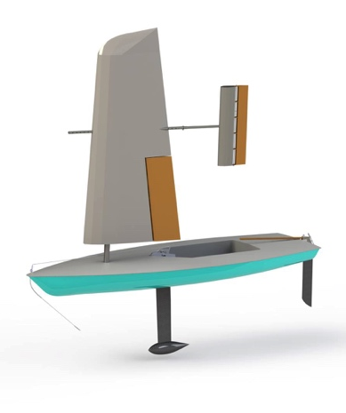
Figure _: Final rigid-wing sailboat concept

Final Wing-sail Components and Implementation
This section details the components used for the realization of a final wing-sail product, which is based on the architecture described in section III. The wings skin coverage, internal structure, wing and stabilizer mechanism, hull to wing-sail configuration and electronic devices are explained.

Skin Coverage
To use maritime plywood is fundamental the use of a glue with the right properties, that we have accounted to be Sikaflex, that is specifically designed for structural bonding in boats, and provide elasticity and high mechanical load capacity. Our final decision was to use wood for the entire sail, excepted for the mast and the stabilizer beam. We use Maritime plywood for all the structural parts as ribs the skin. We use balsa panels to cover the plywood holes done to save weight The other idea is to use wood, in particular maritime plywood for the entire structure of the sail. A good quality marine plywood sail, well constructed and protected will be immensely strong and last a lifetime. Plywood is particularly pliable, this type of wood can be bent and still maintain its structural integrity. There were several parameters influencing our work, in particular the building process, the price, and the purchasing accessibility.

Internal Structure

Masts

Stainless Steel

Wooden Mast

Main Wing Mast

Stabilizer Wing Mast

Lateral Union

Ribs

Stainless Steel Connectors

Mechanical Mechanisms
The control mechanisms of the wing sail consist of both the flaps actuator and the stabilizers servomotor. These instruments must transmit to a control unit, which is further stated in subsection Electrical Devices. The synchronization between both control variables will be done so by this control unit.

Flap Control
The control of this design parameter is completed by an Electric Linear Actuator [http://www.festo.com/cat/pt_pt/data/doc_engb/PDF/EN/EPCO_EN.PDF] with a encoder for positioning control. The allocated actuator is located on a central rib of the main sail and connected to the flap via a 1-metre piano hinge, which acts as a centre of rotation, turning the linear movement of the actuator into a rotation movement for the flap. In addition, the encoder will be configured to shift the stroke to a specific distance that gives 20º to the flap for each side.

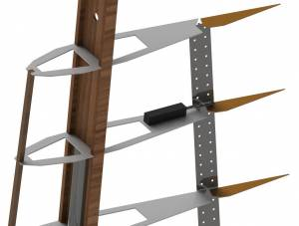
Figure_: Actuator position

Stabiliser Control
The stabiliser unlike the flap control requires less force to maneuver and position, therefore, a servomotor will be has been designated to perform this operation. The servomotor will be situated in the static rib and connected to a vertical shaft with two rigid cables that is fixed to a rotating rib, this will transmit the rotational torque from the servo to the stabiliser position.

The stabiliser is fixed to the wing through a horizontal stainless steel tube with different holes to adapt it on the suitable position. Both tubes will be put together with two screws, one passed horizontally and the other vertically. It will support all strengths from different directions. The front part of the wing tube will has the same distribution of holes but we have not put anything. The idea is to make it adaptable so a counterbalance, a wind sensor or whatever the user wants can be put.

Hull to wing-sail configuration
The connection between sail and hull body has to be accurately designed, considering all parameters of movement. The mast must be able to rotate freely around an angle of 360 degrees, although this must be controlled and limited to prevent destabilization of the rigid-wing sail within the hull. The proposed solution previously stated is to install flange bearings of adequate dimensions to accommodate the 70 mm diameter mast this will stabilize the mast in the body of the hull. These bearings will be lubricated to reduce wear on both the mast and bearing housings

Electronic Devices
It is paramount that the configuration of electrical appliances is predetermined due to our proposed manufacturing process. The system will be enclosed in the skin of the wing this causes great difficulty to renovate the system within the sail. The prospected components and locations at which the will be inserted to the wing are as follows:
- Battery ⇒ Position: Base Rib
- Navigating Lights ⇒ Position: Peak of Rigid-wing sail
- Actuator ⇒ Position: Central Beam of the Flap
- Wind Sensor ⇒ Position: Front Facing Beam
- Servo Motor ⇒ Position: Central Rib of the Stabiliser

This electrical design will let us test the system under certain conditions and ensure our design can accommodate these electronic appliances in terms of positioning and connections. The black box stated in the schematic diagram above is delivered by the autonomous experts at LSA, this will be connected to the hull and deliver commands by acting as the control unit of our sailboat. The connection via these appliances will be Wi-Fi or Bluetooth, which ever the client prefers.

Experimental Tests and Results
A series of tests was required to make the alternative proto-type and implemented rigid-wing sail is working as expected. After testing of the wings externally waterproof and the mechanisms motion is operational, the experimental evaluation of the wing-sail lift value will be presented and discussed.

Waterproofing
The first test to be carried out would be regarding the water resilience. As a matter of fact, there are various possibilities of work not been done at highest standard and precision. Most likely are small gaps between glued parts that cause water coming inside the wing sail. Taking this into consideration and the fact that splash water is foreseen to enter the sail at the connection point of main sail and flap, holes are made at the bottom of the sail to discharge the water. Furthermore, precautions are made to protect electrical devices from incoming water. Either by choosing waterproof devices, or by covering the device with protection measures.

Wing and stabiliser motion
The test of the motion of jib and flap is to be done before the entire sail will be covered and additionally after coverage is done to assure a smooth movement without irritations. The defined target is a movement of ± 20° from 0°. The actuator will position the jib, which is located in the main wing. The actuator is positioned and fixed on a central rib to increase the area of movement this is connected to the motor and control unit this is activated by turning on the remote control. The stabiliser will need to complete this motion in almost the same time as the actuator, thus a degree of synchronisation must be completed and to be monitored upon its correct functioning. As the servomotor in the stabiliser consumes power from the battery and is controlled via remote control from a control unit the right performing is to be investigated. The test will conducted in dry condition outside the water.
The results indicate that both jib and stabiliser move as expected in dry condition. To improve the undulating movement of the jib, the actuator will be extended to enhance a larger angle, which can be manually changed by replacing the rod connected to the actuator and jib. It needs to be tested if this motion of 20 degree's of the jib creates enough movement at the right angle to counteract the wind speed when in operation.

Lift test
The lift test can be performed either in a wind tunnel or the outdoor environment in the best conditions. For both conditions the testing plan will change drastically. Besides not having access to a sufficient wind tunnel, we will strive to perform the test outdoor. Our idea is to position the wing on a fabricated steel bracket, which is limitedly tied down and weighted to prevent collapse during the lift of the wing. The test must be carried out in optimal wind conditions to produce the efficient lift on the wing without flipping and damaging the wing. Our idea is to remove weight from the support bracket until an upwards-lifting force can be seen. The target is to acquire its maximum weighted lift. This value will be used to meet the predetermined calculations and justify our decisions in building the wing in this form.

Conclusion and Future Work
In the beginning of this project, detailed knowledge about the research field has been gathered, although halfway during the course the attention had been changed becoming concisely fixed on a new goal of a rigid-wing sail. Although not a new topic, the design for a rigid sail was recently discovered by our team thus vast amounts of research. This concerned the competitors and laws of physics that served as groundwork for the product development and confirmed the innovative individuality for the client.

Based on the state of the art, a rigid-wing sail prototype was developed using aircraft wing principles and the stability of a floating object in sea conditions. These physical theories when put into practice ensures steering with a command-response pattern that is easy to handle. The key concepts are the actuator and servomotors control the steering parameters in two variables of the sail design, acting simultaneously to counter act the forces and optimize sail direction. The innovative concept has been incapable of functionality tests due to the short amount of time available for the experimental evaluation, no functionality tests could be performed. Nevertheless, the controllable variables already revealed its potential to control the wing with its concepts research from archives of professional organizations. The expectation to improve the efficiency significantly can be applied by fully testing and adapting the mechanism to fit the suited environment of operation. Our group members have developed in each individual’s respective area of study, project management and ecological rationality. The experience focus was partially on the functionality as a team and how we collaborated, tasked and controlled while being culturally and academically challenged.

Following this project, we have categorized both short-term and long-term goals that will see provide a fully furnished product to the client. The initial short-term goal will be to establish a wing-sail with quality components and completion of all functional tests with satisfactory results. At this time no initially proposed requirements where practically fulfilled, only the theoretical concepts have been produced for the project. The final short-term goal will be to reduce the amount of toxic and harmful materials, holding paramount the enhancement of safety for the user and environment.

Although the initial purpose has been obstructed we have still produced quality models and concepts for the long-term development of an autonomous sailboat. This long-term goal will include the integration of initiating a suitable platform while considering sustainable measures of energy generation. In addition, the user manual can be elaborated further to allow users to assemble and programmable route manager as the innovative product can be characterized especially to individual customers.as the conclusion. A conclusion might elaborate on the importance of the work or suggest applications and extensions.

Acknowledgment
After completion of the project of the rigid-wing sail, we want to thank the teachers involved in the academic classes, as well as the supervisors that guided us patiently throughout the course of the semester. It was a profitable experience, full of hard work, and great companionships as team members to friends have been developed on both a cultural and academic level. The authors want to give a special thanks to Fernando Ferreira as the main project advisor for his guidance and support to the development of the project.

References

References
Number citations consecutively in square brackets [1]. The sentence punctuation follows the brackets [2]. Multiple references [2], [3] are each numbered with separate brackets [1]–[3]. When citing a section in a book, please give the relevant page numbers [2]. In sentences, refer simply to the reference number, as in [3]. Do not use “Ref. [3]” or “reference [3]” except at the beginning of a sentence: “Reference [3] shows ....”

- http://link.springer.com/chapter/10.1007%2F978-3-319-10076-0_5#page-1
- OCEAN 71%...
- G. O. Young, “Synthetic structure of industrial plastics (Book style with paper title and editor),” in Plastics, 2nd ed. vol. 3, J. Peters, Ed. New York: McGraw-Hill, 1964, pp. 15–64.
- W.-K. Chen, Linear Networks and Systems (Book style). Belmont, CA: Wadsworth, 1993, pp. 123–135.
- H. Poor, An Introduction to Signal Detection and Estimation. New York: Springer-Verlag, 1985, ch. 4.
- B. Smith, “An approach to graphs of linear forms (Unpublished work style),” unpublished.
- E. H. Miller, “A note on reflector arrays (Periodical style—Accepted for publication),” IEEE Trans. Antennas Propagat., to be published.
- J. Wang, “Fundamentals of erbium-doped fiber amplifiers arrays (Periodical style—Submitted for publication),” IEEE J. Quantum Electron., submitted for publication.
- C. J. Kaufman, Rocky Mountain Research Lab., Boulder, CO, private communication, May 1995.
- Y. Yorozu, M. Hirano, K. Oka, and Y. Tagawa, “Electron spectroscopy studies on magneto-optical media and plastic substrate interfaces(Translation Journals style),” IEEE Transl. J. Magn.Jpn., vol. 2, Aug. 1987, pp. 740–741 [Dig. 9th Annu. Conf. Magnetics Japan, 1982, p. 301].
- M. Young, The Technical Writers Handbook. Mill Valley, CA: University Science, 1989.
- J. U. Duncombe, “Infrared navigation—Part I: An assessment of feasibility (Periodical style),” IEEE Trans. Electron Devices, vol. ED-11, pp. 34–39, Jan. 1959.
- S. Chen, B. Mulgrew, and P. M. Grant, “A clustering technique for digital communications channel equalization using radial basis function networks,” IEEE Trans. Neural Networks, vol. 4, pp. 570–578, July 1993.
- R. W. Lucky, “Automatic equalization for digital communication,” Bell Syst. Tech. J., vol. 44, no. 4, pp. 547–588, Apr. 1965.
- S. P. Bingulac, “On the compatibility of adaptive controllers (Published Conference Proceedings style),” in Proc. 4th Annu. Allerton Conf. Circuits and Systems Theory, New York, 1994, pp. 8–16.

Helpful Hints

Figures and Tables
Large figures and tables may span both columns. Place figure captions below the figures; place table titles above the tables. If your figure has two parts, include the labels “(a)” and “(b)” as part of the artwork. Please verify that the figures and tables you mention in the text actually exist. Please do not include captions as part of the figures. Do not put captions in “text boxes” linked to the figures. Do not put borders around the outside of your figures. Use the abbreviation “Fig.” even at the beginning of a sentence. Do not abbreviate “Table.” Tables are numbered with Roman numerals.
The paper is only printed in black-white color. Figure axis labels are often a source of confusion. Use words rather than symbols. As an example, write the quantity “Magnetization,” or “Magnetization M,” not just “M.” Put units in parentheses. Do not label axes only with units. As in Fig. 1, for example, write “Magnetization (A/m)” or “Magnetization (Am⁻¹),” not just “A/m.” Do not label axes with a ratio of quantities and units. For example, write “Temperature (K),” not “Temperature/K.”
Multipliers can be especially confusing. Write “Magnetization (kA/m)” or “Magnetization (10³ A/m).” Do not write “Magnetization (A/m) × 1000” because the reader would not know whether the top axis label in Fig. 1 meant 16000 A/m or 0.016 A/m. Figure labels should be legible, approximately 8 to 12 point type.

Abbreviations and Acronyms
Define abbreviations and acronyms the first time they are used in the text, even after they have already been defined in the abstract. Abbreviations such as IES, SI, ac, and dc do not have to be defined. Abbreviations that incorporate periods should not have spaces: write “C.N.R.S.,”

Other Recommendations
Use one space after periods and colons. Hyphenate complex modifiers: “zero-field-cooled magnetization.” Avoid dangling participles, such as, “Using (1), the potential was calculated.” [It is not clear who or what used (1).] Write instead, “The potential was calculated by using (1),” or “Using (1), we calculated the potential.”

Fig. 3 mapping nonlinear data to a higher dimensional feature space
Use a zero before decimal points: “0.25,” not “.25.” Use “cm³,” not “cc.” Indicate sample dimensions as “0.1 cm × 0.2 cm,” not “0.1 × 0.2 cm².” The abbreviation for “seconds” is “s,” not “sec.” Do not mix complete spellings and abbreviations of units: use “Wb/m²” or “webers per square meter,” not “webers/m².” When expressing a range of values, write “7 to 9” or “7-9,” not “7~9.”
A parenthetical statement at the end of a sentence is punctuated outside of the closing parenthesis (like this). (A parenthetical sentence is punctuated within the parentheses.) In American English, periods and commas are within quotation marks, like “this period.” Other punctuation is “outside”! Avoid contractions; for example, write “do not” instead of “don’t.” The serial comma is preferred: “A, B, and C” instead of “A, B and C.”
If you wish, you may write in the first person singular or plural and use the active voice (“I observed that ...” or “We observed that ...” instead of “It was observed that ...”). Remember to check spelling. If your native language is not English, please get a native English-speaking colleague to proofread your paper.

Submitted on the 12th June 2015. This work was financially supported by LSA - Autonomous Systems Laboratory, ISEP, Instituto Superior de Engenharia do Porto, 4200-072 Porto, Portugal. R. G. is with the Politecnico di Torino, Torino, 10129, Italy. (e-mail: s191842@polito.it). G. J. R. is with Glasgow Caledonian University, Glasgow, G4 0BA, UK. (e-mail: grabon200@gcu.ac.uk). M. N. H. is with the Escola Politècnica Superior d'Enginyeria de Vilanova I la Geltrú, 08800 Vilanova I la Geltrú, Barcelona, Spain. (e-mail: marc.navarrete.hill@upc.edu.es). I. A. is with the University of Budapest, Budapest, Hungary. (e-mail: imre0211@gmail.com). T. G. is with Kiel University of Applied Science, Kiel, 24118, Germany. (e-mail: thies.guenther@student.fh-kiel.de).

