Project Title
Autonomous Sailing Boat

Sponsor
Autonomous Systems Laboratory (LSA)
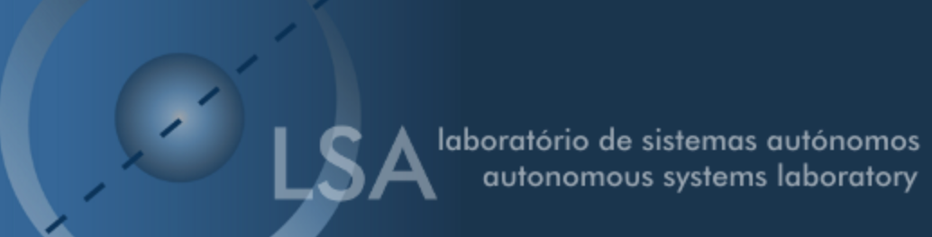

Project Summary
The goal is to build an autonomous sailing boat.
The project requirements are:
- Selection of components;
- Specification of the power, sensor, actuator and control modules;
- Use open source and freeware software;
- Comply with the following EU Directives:
  - Machine Directive (2006/42/CE 2006-05-17);
  - Electrical Safety: Low Level Voltage Directive (2006/95/CE 2006-12-12);
  - Restriction of Hazardous Substances (ROHS) in Electrical and Electronic Equipment Directive (2002/95/EC 2003-01-27);
- Mandatory adoption and use of the International System of Units (The NIST International Guide for the use of the International System of Units).

Participants
Institution: Instituto Superior de Engenharia do Porto
Team Number: 5
Students:
- Roberto Giordano
- Gary Jonathan Rabone
- Marc Navarrete Hill
- Imre Asztalos
- Thies Gunther
Panel of Supervisors:
- Abel Duarte (ajd@isep.ipp.pt)
- Fernando Ferreira (fjf@isep.ipp.pt)
- Luís Lima (lul@isep.ipp.pt)
- Maria Benedita Malheiro (mbm@isep.ipp.pt)
- Maria Cristina Ribeiro (mcr@isep.ipp.pt)
- Paulo Ferreira (pdf@isep.ipp.pt)
- Pedro Barbosa Guedes (pbg@isep.ipp.pt)
Client:
- LSA - Eduardo Silva, eaps@lsa.isep.ipp.pt, etc.

Contents
Project Planning: Deadlines, Tasks, Gantt chart, Task allocation
Logbook: Weekly Report, Meetings, Activities
Report: Report
Deliverables: Links to all deliverables

Contacts
- Roberto Giordano, rob.giordi@hotmail.it, facebook, twitter, etc.
- Gary Jonathan Rabone, jonny.rabone@gmail.com, facebook.com/rabone1, twitter.com/JonnyRabone, etc.
- Marc Navarrete Hill, navamarc@hotmail.com, facebook, twitter, etc.
- Imre Asztalos, imre0211@gmail.com, facebook.com/asztalos.imre1, twitter, etc.
- Thies Gunther, th.gu@web.de, facebook, twitter, etc.

Utilities
- DokuWiki Syntax
- Videos on how to use Wikidoku

Acknowledgements
- Sponsor (sponsor)
- Eng.º Vítor Costa Cerqueira, DEE, ISEP (wiki installation and management)
- Prof. João Correia Lopes, DEI, FEUP (wiki template)
— EPS@ISEP Wiki Template 2012-01-15 15:35

