Work plan

Deadlines
- 2015-03-02 Choose a project proposal and send the result via email to epsatisep@gmail.com
- 2015-03-11 Define the Tasks (what must be done), Task allocation (who does what) and Gantt chart (when) of the project and insert them on the wiki (planning)
- 2015-03-27 Specify the list of material (what, quantity, where to buy - local companies are mandatory) on the wiki
- 2015-04-05 Upload the Interim Report and Presentation to the wiki; the report should contain the Introduction, including the tasks, team members allocation and Gantt chart, State of the Art, Marketing Plan, Project Management, Eco-eficiency Measures for Sustainability, Ethical and Deontological Concerns, Proposed Solution and Bibliography chapters
- 2015-04-09 Interim Presentation, Discussion and Assessment
- 2015-06-12 Upload the Final Report, Presentation, Video, Paper, Poster and Manual
- 2015-06-18 Final Presentation, Individual Discussion and Assessment
- 2015-06-25:
  - Update the wiki with all correction suggestions
  - Hand in a CD with the corrected deliverables (source + PDF) together with all code produced to the EPS coordinator
  - Hand in one printed exemplar of the corrected report to the EPS coordinator
- 2015-06-26:
  - Hand in the prototype and user manual to the client
  - Receive the EPS@ISEP certificate

Tasks
Task | Responsible
Project Selection | Entire Team
Gantt Chart | Imre and Thies
Team building Presentation | Entire Team
Leaflet | Thies
Material Research and Selection | Entire Team
State of the Art | Jonny and Marc
Marketing | Roberto and Thies
Energy and Sustainability | Imre
Ethics and Deontology | Gizem
Investigation | Entire Team
Planning | Entire Team
Development | Entire Team
Testing | Entire Team
Interim Report/Presentation | Entire Team
Final Report/Presentation | Entire Team
Poster | Marc and Imre
Paper | Gizem and Roberto
Manual | Entire Team
Video | Imre and Jonny
Logbook | Entire Team
Website | Jonny

Gantt Chart
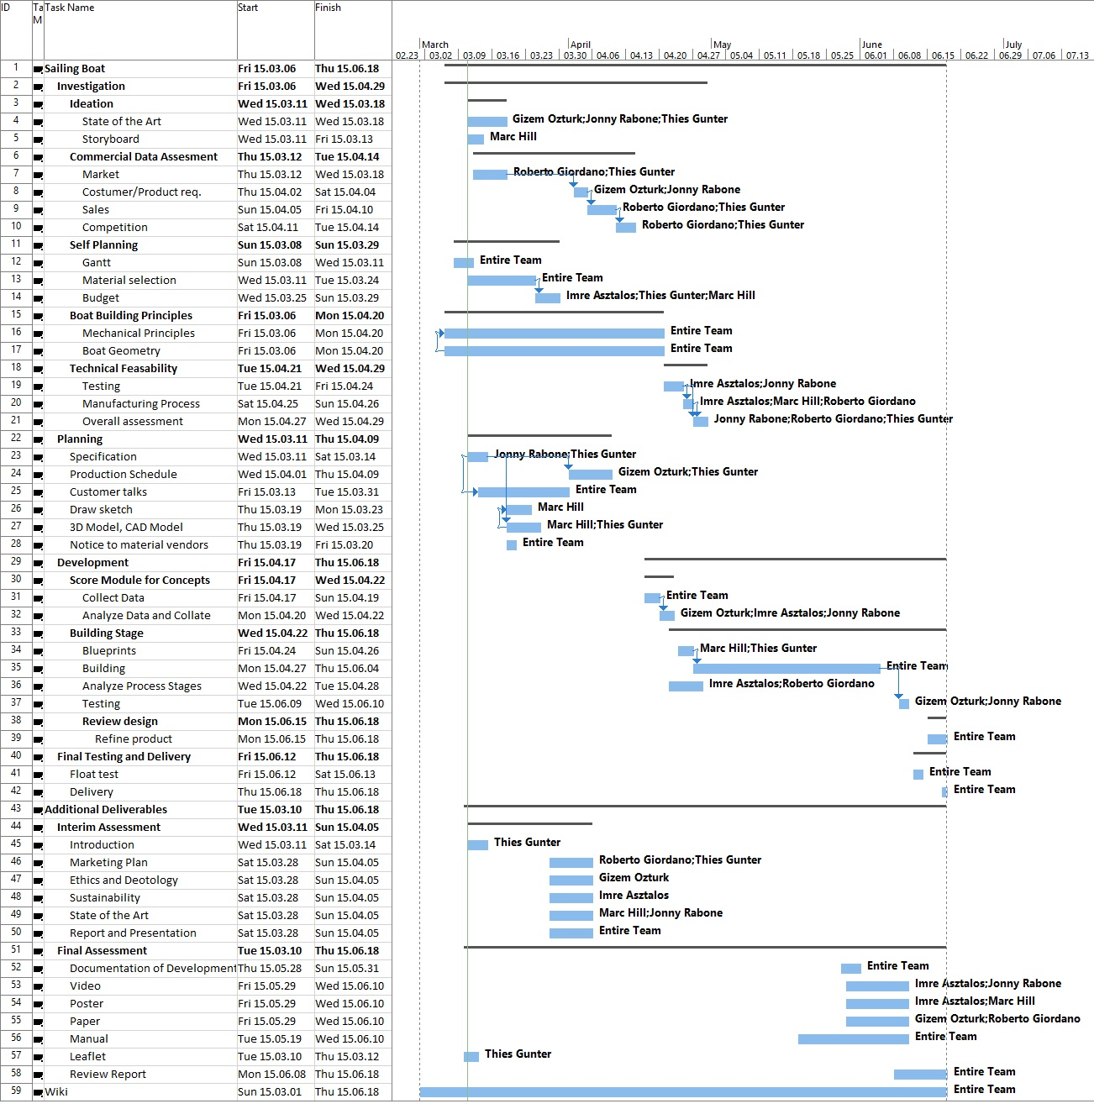

Alternative Gantt Chart


